|  |  |  |  |  |  |  |  |  |
| --- | --- | --- | --- | --- | --- | --- | --- | --- |
| |  | | --- | | Tidal Audio Streamer ARKAS | | https://audiohoanghai.com/media/product/8128-1_7.jpg |  |  |  |  |  | | --- | --- | --- | --- | |  |  | https://audiohoanghai.com/media/product/8128-atlas_ddnb.jpg |  | |  | **Specifications:**  **Structure:** Multi-core  **Material:** 6n OFC  **Dielectric:** PTFE (Teflon™)  **Capacitance:** 73.42 pF/m  **Inductance:** 0.5178 µH/m  **Resistance:** 0.0104Ohms/m  **VOP:** 0.695 Outside  **Outer diameter:** 3.5 X 7.0mm (rectangular part)  **Price: 399$** |

**Overview:**

**Atlas Hyper 2.0 speaker cable | Audio FOTOLAB**

Atlas Hyper 2.0 speaker cables feature very high purity (99.9999%) OFC (Oxygen Free Copper) with advanced dielectric (Teflon™) conductors. This is a great combination and it means the cable delivers outstanding performance, well suited to audio systems. The increased diameter conductors on the Atlas Hyper 2.0 provide improved bass performance compared to the 1.5 version.

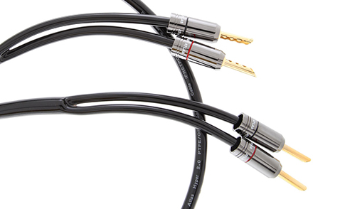

**Outstanding features of Atlas Hyper 2.0 Speaker Cable:**

Atlas Z-Plugs

OFC conductor

PEF dielectric

Multi-core structure

**Atlas Z-Plugs**

Atlas' exclusive Z plug is a low-mass, self-cleaning, solder-free speaker plug.

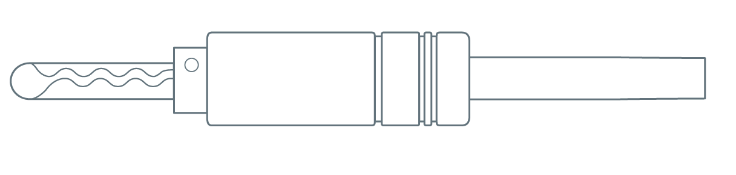

**OFC conductor**

OFC is produced through an extrusion process that takes place in an inert gas environment without oxygen. This results in reduced oxygen content (10 ppm) when compared to Tough Pitch Copper (TPC) and improved conductivity typically measuring 0.5% to 2% higher than TPC. Therefore, the OFC process produces much higher quality audio cables than the TPC process. High purity conductors provide clearer sound than untreated (TPC) conductors because there are fewer crystal boundaries to cause signal attenuation.

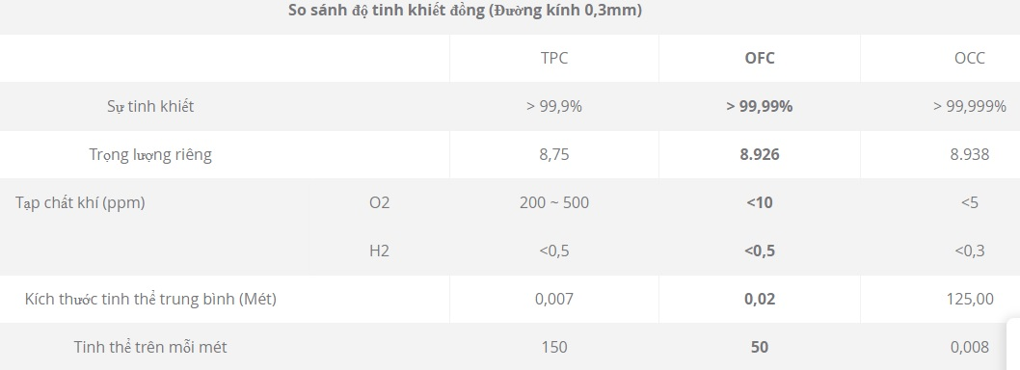

**PEF dielectri**

PVC (Poly Vinyl Chloride) is cheap to produce, so it is the most commonly used insulator in AV cables. However, PVC is the poorest quality insulation that a Hi-Fi or AV signal can encounter because its high attenuation significantly reduces signal speed. Therefore PVC is only suitable for power cables

Other commonly used dielectrics are Polyethylene, Polypropylene and Polytetrafluoride Epoxy (better known as PTFE (Teflon™) or Teflon,).

HDPE (High Density Polyethylene) has a more tightly packed structure than its more flexible cousin LDPE (Low Density PE) and is superior in its durability.

**Multi-core structure**

A pair of identical conductors (one conducts the signal, the other serves as the return conductor) are enclosed in a non-conductive screen.